**1) Create new menu item.**

All the possible errors are demonstrated below in Fig 1.1

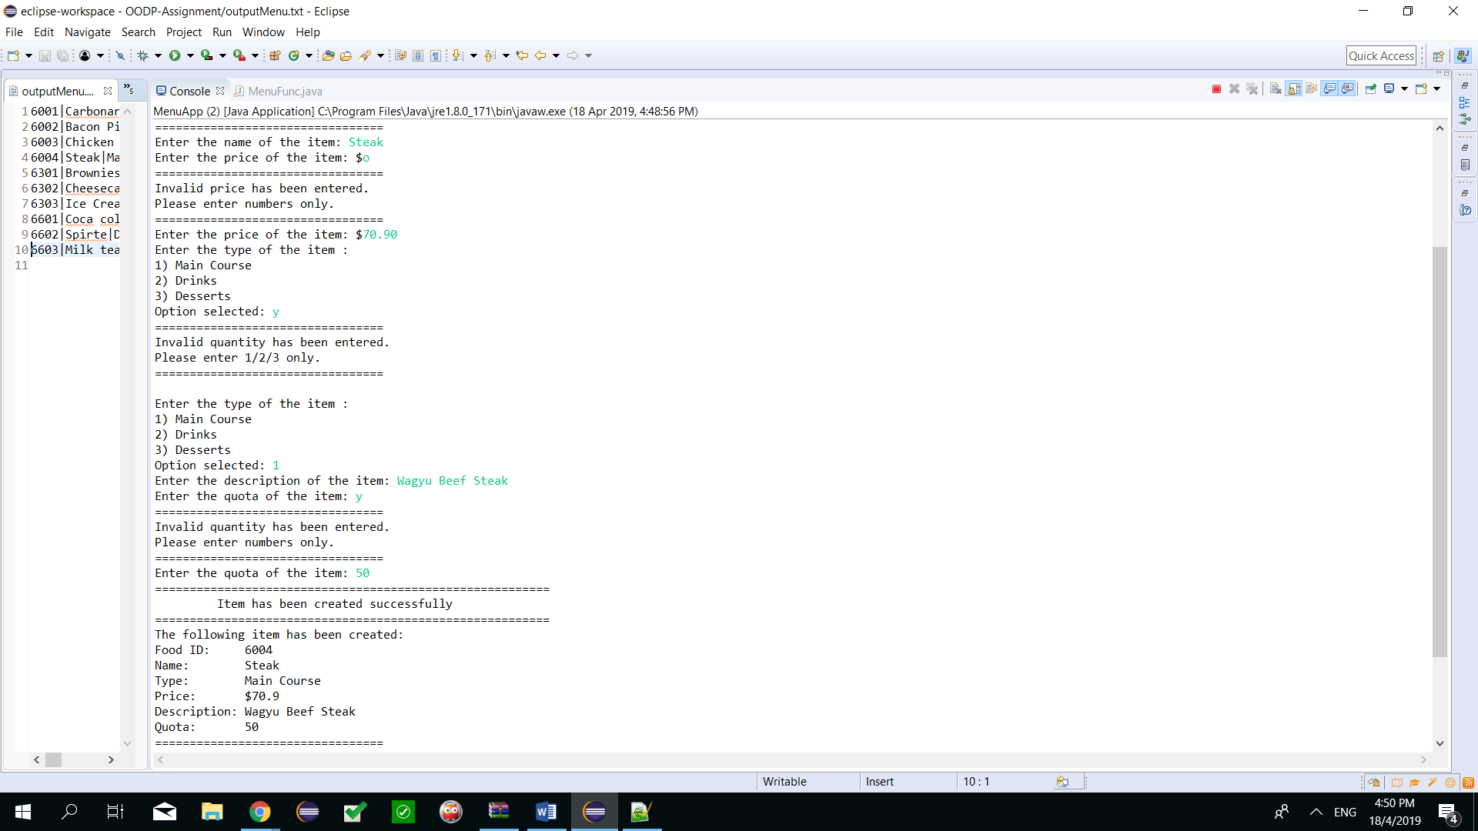



**Fig 1.1: Test case with all possible errors caught**

**2) Update a menu item.**

Editing an item would require the user to enter a targetID and if it does not exist will prompt for another ID that has to be valid.

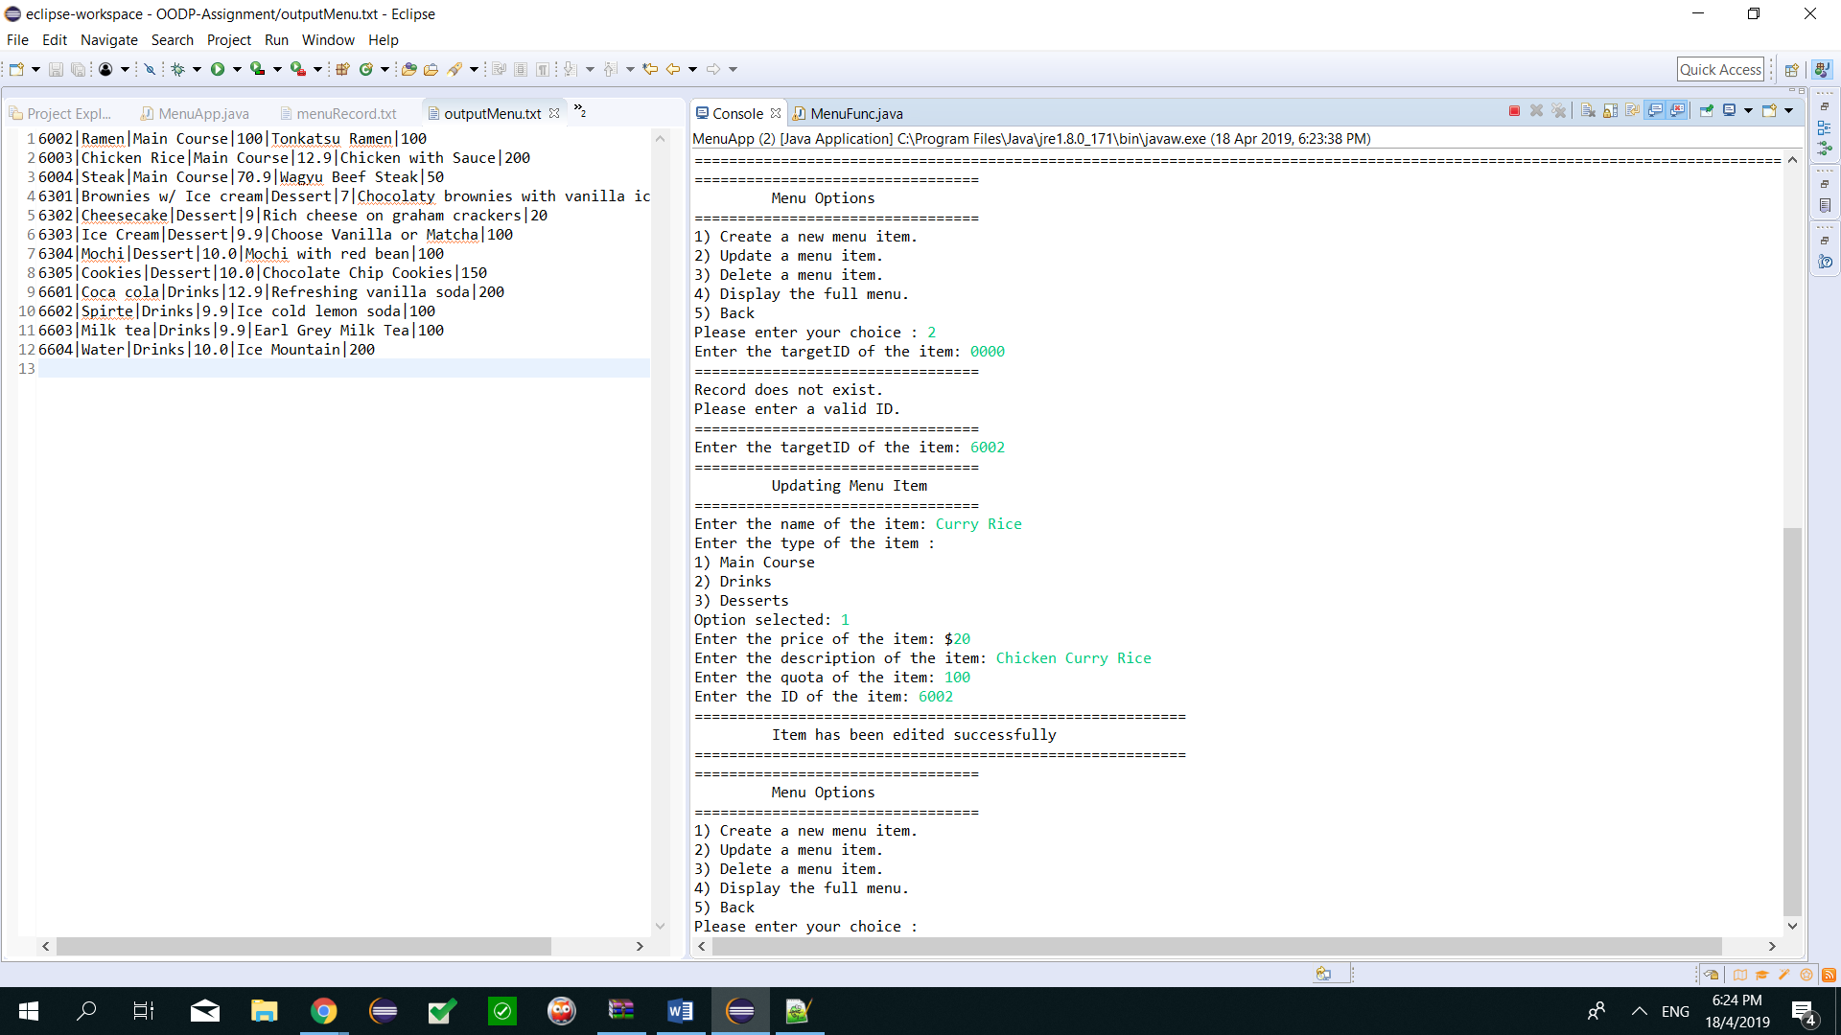

**3) Delete a menu item.**

Delete function will always check if the target ID exist. If it does not an error message is returned, otherwise it will ask for a confirmation before delete as seen in Fig 4.1

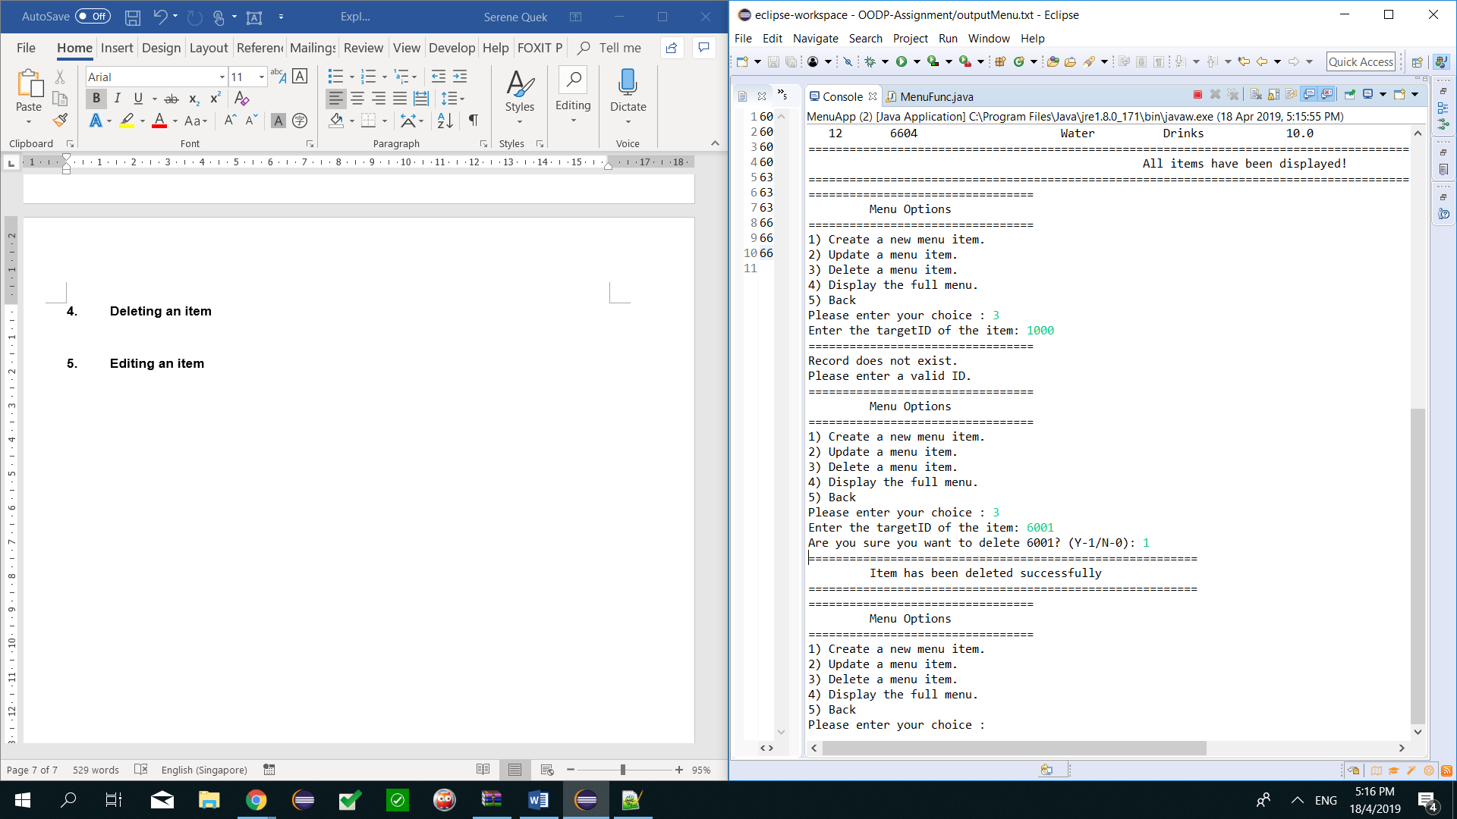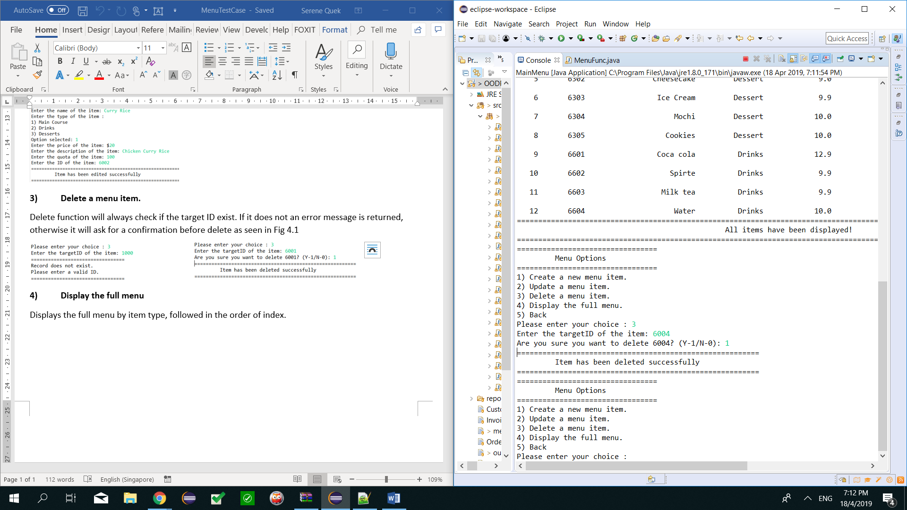

**4) Display the full menu**

Displays the full menu by item type, followed in the order of index.